 | B.N.M. Institute of Technology  An Autonomous Institution under VTU

Java Programming and its Applications (23ECE164)
6th SEMESTER

(Project Based Learning Course)

PROJECT REPORT
ON

“The Smart Digital Twin Classroom Monitoring System”

by

Akanksha V 1BG23EC006
Chaithra M R 1BG23EC019

Under the guidance of
Dr. Jyoti R Munavalli
Professor

Department of Electronics & Communication Engineering
2025-26

B.N.M. Institute of Technology

An Autonomous Institution under VTU, Approved by AICTE, Accredited as ‘A’ Grade Institution by NAAC till 31.12.2026
All Eligible UG branches – CSE, ECE, EEE & ISE . Accredited by NBA till 30.06.2028
Post box no. 7087, 27th cross, 12th Main, Banashankari 2nd Stage, Bengaluru- 560070, INDIA
Ph: 91-80- 26711780/81/82 Email: principal@bnmit.in, www.bnmit.org

Department of Electronics and Communication Engineering



CERTIFICATE

Certified that the Project titled “The Smart Digital Twin Classroom Monitoring System” carried out by Akanksha V(1BG23EC006), and Chaithra M R(1BG23EC019), bona fide students of VI semester, during the year 2025-2026, for the fulfillment of the academic requirements for the Project Based Learning Course Java Programming and its Applications (23ECE164). The Project report has been approved as it satisfies the academic requirements for the course.

Dr. Jyoti R Munavalli | Dr. Yasha Jyothi M Shirur
Professor | Professor and Head
Dept. of ECE | Dept. of ECE
BNMIT, Bangalore | BNMIT, Bangalore

External Examination:

Sl. No. | Name of the Examiners | Signature and date
1
2

ABSTRACT

Digital Twin technology is an emerging approach used to create virtual representations of physical systems for monitoring, simulation, and performance analysis. In educational environments, smart classroom monitoring systems help improve resource utilization, student comfort, and infrastructure efficiency. This project presents the design and implementation of a Smart Digital Twin Classroom Dashboard, which simulates real-time classroom conditions using software-based visualization techniques.
The proposed system models a virtual classroom environment capable of monitoring student attendance, temperature variations, energy consumption, and comfort levels through an interactive graphical dashboard developed using Java Swing. Attendance data is imported from a CSV dataset and used to dynamically update seat occupancy within the classroom layout. Based on classroom occupancy and lecture activity status, the system automatically simulates environmental changes such as temperature variation and energy usage caused by lighting, fans, projectors, and air conditioning units.
The dashboard includes graphical visualization of temperature and energy trends over time, providing insights into classroom behavior through real-time monitoring graphs. In addition, automation features such as lecture control toggling and comfort-level prediction enhance the functionality of the system by demonstrating intelligent classroom management concepts. A report generation feature is also included to summarize classroom operational data for analysis purposes.
This project demonstrates how Digital Twin technology principles can be applied to simulate smart classroom environments without requiring physical sensor deployment at the prototype stage. The proposed system provides a scalable framework that can be extended in the future with IoT sensor integration and cloud-based monitoring to support smart campus infrastructure aligned with Industry 4.0 developments.

ACKNOWLEDGEMENTS

The satisfaction and euphoria that accompany the successful completion of the Java Programming and its Application Project would be incomplete without mentioning the names of the people who made it possible.
We express our heartfelt gratitude to B N M Institute of Technology, for giving us the opportunity to pursue Degree of Electronics and Communication Engineering and helping us to shape our career. We take this opportunity to thank Prof. T. J. Rama Murthy, Director, BNMIT, Dr. S.Y Kulkarni, Additional Director and Principal, BNMIT, Dr. Krishnamurthy. G. N, Deputy Director, BNMIT and Prof. Eishwar N Maanay, Dean, BNMIT, for their support and encouragement to pursue this project. We would like to thank Dr. Yasha Jyothi M Shirur, Professor and Head, Dept. of Electronics and Communication Engineering, for her support and encouragement.

It is with a deep sense of gratitude and great respect; we owe our indebtedness to our guide Dr. Jyoti R Munavalli, Professor and Head, Innovations & ED Cell. We thank her for her constant encouragement during the execution of this project.

We thank our parents, without whom none of this would have been possible. Their patience and blessings have been with us at every step of this Project. We would express our thanks to all our friends and all those who have helped us directly or indirectly for the successful completion of the Project.

Akanksha V

Chaithra M R

TABLE OF CONTENTS

Abstract……………………………………………………………………….... i
Acknowledgements.……………………………………………………………. ii
List of Figures…………………………………………........................................iv
List of Tables……………………………………………………………………. v
List of Abbreviations……………………………………………………………. v
Chapter 1- Introduction……………………………………….………………….1
Chapter 2-Literature Survey………………………………….…………………. 3
Chapter 3- Implementation of Proposed System …………………..................... 5
Chapter 4- Results and Discussion …….……………………….……………… 13
Chapter 5- Conclusion and Future Scope………………….…………………... 19

References

LIST OF FIGURES

Figure No. | Description | Page No
Figure 3.1 | Block Diagram of the Proposed System | 5
Figure 3.2 | Attendance CSV File | 7
Figure 4.1 | Dashboard output Before Activating Lecture Mode | 13
Figure 4.2 | Dashboard output After Activating Toggle Lecture Mode | 15
Figure 4.3 | Classroom Monitoring Report After Export | 16

LIST OF TABLES

Table No. | Description | Page No
TABLE 3.1 | CSV Attendance File Structure | 7
TABLE 3.2 | Dashboard Parameters Displayed in System | 10
TABLE 3.3 | Software Modules and Their Functions | 12

LIST OF ABBREVIATIONS

CSV – Comma Separated File

Chapter 1
INTRODUCTION
  - Motivation
With the advancement of smart infrastructure technologies and digital monitoring platforms, educational institutions are gradually adopting intelligent systems to improve classroom management and learning environments. Traditional classroom monitoring methods rely heavily on manual observation and static attendance records, which do not provide real-time insights into environmental conditions or student occupancy patterns. This limitation creates challenges in maintaining comfortable learning environments and optimizing energy usage inside classrooms. The concept of Digital Twin technology, which creates a virtual representation of a physical system, offers an efficient solution to simulate and monitor classroom conditions dynamically. Motivated by the need for smarter classroom monitoring systems, this project focuses on designing a Digital Twin Classroom Dashboard capable of representing classroom occupancy, environmental conditions, and energy usage through a unified visualization platform. The system demonstrates how software-based simulation techniques can support intelligent classroom monitoring even without physical IoT sensor deployment.

1.2 Problem Statement
In conventional classroom environments, there is no integrated system available to simultaneously monitor student attendance distribution, classroom environmental conditions, and energy consumption behavior in real time. Most institutions still depend on manual attendance tracking methods and separate environmental control systems that operate independently without coordination. This lack of integration leads to inefficient resource utilization, reduced environmental comfort awareness, and limited monitoring capabilities. Therefore, there is a need for a centralized dashboard system that can simulate classroom infrastructure behavior and provide real-time visualization of occupancy status, temperature variations, comfort conditions, and energy usage patterns within a single interface. The Digital Twin Classroom Dashboard project addresses this issue by developing a software-based monitoring system that replicates classroom behavior using structured data inputs and simulation models.

  - Objective and Scope
The primary objective of this project is to design and implement a Digital Twin Classroom Dashboard using Java that can simulate classroom monitoring functions such as attendance visualization, environmental condition tracking, comfort prediction, and energy usage monitoring. The system reads attendance data from a CSV file, generates a graphical classroom seating layout, simulates temperature variations, evaluates classroom comfort levels, and displays dynamic energy consumption behavior through waveform graphs. Additionally, the system provides automation functionality through lecture mode control and generates monitoring reports for documentation purposes. The scope of this project is limited to simulation-based implementation without hardware sensor integration; however, the system architecture is designed in such a way that it can be extended in the future for real-time IoT-based classroom monitoring applications.

1.4 Organization of Project Report
This project report is organized into multiple chapters to explain the development and implementation of the Digital Twin Classroom Dashboard systematically. The introduction chapter presents the motivation, problem statement, objectives, and scope of the project. The literature survey chapter discusses existing smart classroom monitoring approaches and related technologies. The methodology chapter explains the system architecture, block diagram, and workflow of the proposed model. The implementation chapter describes the software modules and their integration in detail. The results and discussion chapter presents the dashboard outputs and performance observations. Finally, the conclusion and future scope chapter summarizes the outcomes of the project and highlights possible improvements for future development.

Chapter 2
LITERATURE SURVEY

- In 2022, Thelen et al. presented a comprehensive review of digital twin technology, focusing on modeling techniques and enabling technologies. The study highlighted that digital twins enable real-time monitoring, predictive analysis, and system optimization by creating synchronized virtual replicas of physical systems, making them highly suitable for smart environments and intelligent decision-making. [1]

- In the same year, Razzaq et al. introduced the “DeepClassRooms” framework, which applies deep learning techniques to digital twin-based classroom environments. The study demonstrated that integrating real-time classroom data with intelligent models can enhance student engagement, improve monitoring accuracy, and support efficient academic management. [2]

- In 2023, research on digital twin-based smart classroom systems emphasized the importance of real-time data acquisition and automation. These systems were shown to effectively monitor classroom conditions, manage occupancy, and optimize device usage, thereby improving overall classroom efficiency and supporting smart education initiatives. [3]

- Another 2023 study focused on the architectural design of digital twin systems, identifying key components such as physical entities, virtual models, and communication layers. This work established a strong foundation for implementing digital twin technology in dynamic environments like classrooms, where continuous interaction between real and virtual systems is required. [4]

- In 2024, Zhang et al. investigated the effectiveness of digital twin learning systems in engineering education. The study revealed that digital twins enhance learning outcomes by providing real-time interaction and bridging the gap between theoretical knowledge and practical applications. [5]

- Further research in 2024 explored the application of digital twin technology in smart education systems, emphasizing benefits such as improved energy efficiency, real-time monitoring, and enhanced decision-making capabilities. These studies demonstrated that digital twins can significantly contribute to sustainable and intelligent educational environments. [6]

- Another 2024 study by Bäcklund et al. focused on digital twins for educational buildings, highlighting their role in improving occupant comfort and achieving energy-efficient operations. The research showed that integrating environmental parameters such as temperature and occupancy can optimize building performance and user experience. [7]

- Recent advancements in 2025–2026 have focused on integrating artificial intelligence with digital twin systems. Kabashkin (2025) proposed AI-based digital twins of students for personalized learning, while Boudine et al. (2026) demonstrated the use of digital twins in ensuring transparency in educational processes. These studies indicate a shift toward intelligent, adaptive, and data-driven educational systems, aligning with the objectives of smart classroom technologies. [8]

Compared to the existing literature on digital twin–based smart classroom systems, the proposed Digital Twin Classroom Dashboard project provides a practical and simplified implementation of digital twin concepts using a software-based simulation approach suitable for educational environments without requiring complex IoT infrastructure. While earlier studies such as those by Thelen et al., Razzaq et al., and Zhang et al. focused on real-time sensor integration, deep learning frameworks, and intelligent learning systems, this project demonstrates a modular dashboard architecture that integrates attendance visualization from CSV data, environmental condition simulation, comfort prediction logic, and dynamic energy monitoring within a single interactive interface. The key advancement of this work lies in its accessibility and extensibility, as it creates a foundation-level digital twin platform that can later support real-time sensor inputs and AI-based analytics, making it highly useful for smart campus monitoring and resource optimization applications.

Chapter 3
IMPLEMENTATION OF PROPOSED SYSTEM
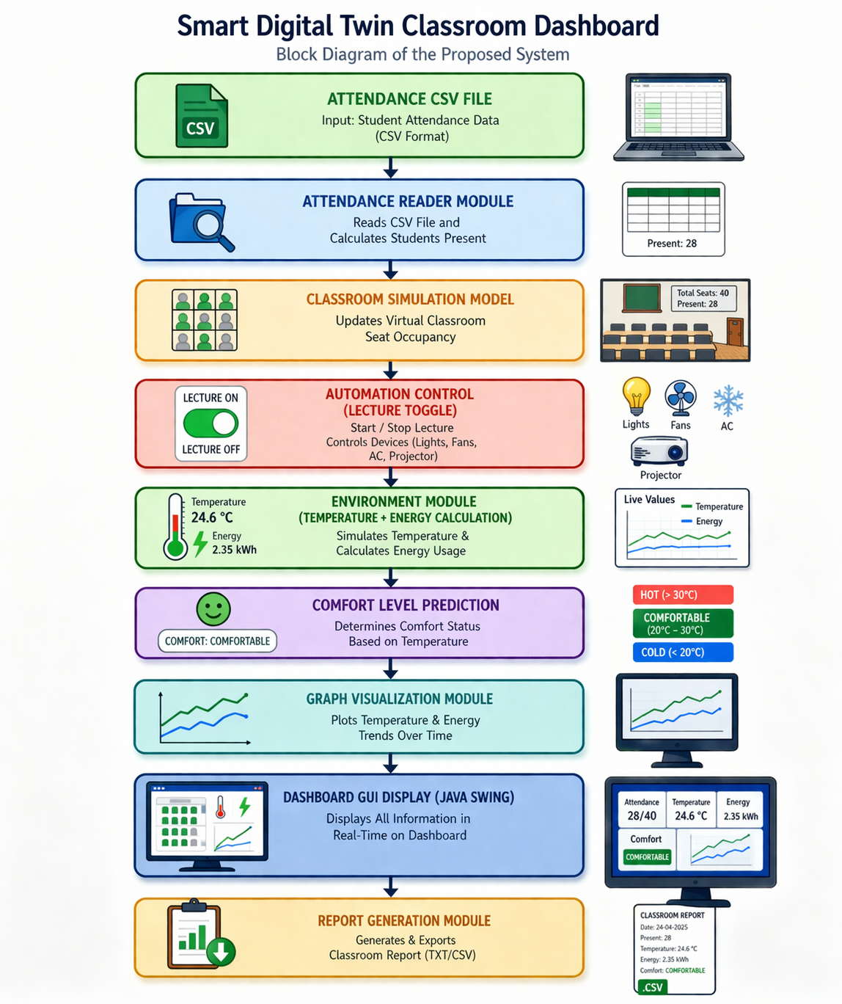
Fig 3.1 Block Diagram of the Proposed System
The Digital Twin Classroom Dashboard system is implemented using a structured modular architecture developed in Java, where multiple interconnected classes collectively simulate a smart classroom monitoring environment. The implementation is organized inside the digitaltwin package and consists of several functional modules including MainGUI.java, Classroom.java, ClassroomPanel.java, AttendanceReader.java, AttendancePredictor.java, EnvironmentModel.java, EnergyManager.java, and EnergyGraphPanel.java. Each module performs a dedicated task within the system and contributes toward creating a virtual replica of classroom conditions. The system integrates attendance processing, classroom visualization, environmental monitoring simulation, energy consumption modeling, comfort prediction logic, lecture automation control, and report generation into a unified graphical dashboard interface.
This modular implementation approach ensures that each subsystem operates independently while communicating with other modules through shared data objects and event-driven updates, thereby achieving the functionality required for a Digital Twin Classroom monitoring platform.
The execution of the system begins with the MainGUI.java class, which acts as the primary control module and graphical interface manager of the Digital Twin Classroom Dashboard. This class initializes the main application window using Java Swing components such as JFrame, JPanel, JLabel, and JButton, and organizes the layout of the dashboard into multiple visualization sections including attendance display area, classroom seat visualization panel, environmental monitoring panel, energy monitoring graph section, and control buttons. The MainGUI class establishes connections between backend modules such as AttendanceReader, Classroom, EnvironmentModel, EnergyManager, and AttendancePredictor so that data generated from these modules can be displayed dynamically on the dashboard. It also handles user interaction through the Toggle Lecture button and Export Report button, both of which trigger event-driven updates inside the system. Because it integrates multiple subsystems and coordinates their communication, MainGUI.java serves as the central backbone of the entire digital twin classroom monitoring system.
The classroom occupancy data used in the system is obtained from an external CSV file, which acts as the primary real-world input source for the digital twin model. This CSV file contains student attendance records arranged in two columns representing student names and attendance status values such as Present or Absent. The AttendanceReader.java class is responsible for loading this CSV file during runtime and extracting attendance information from it. The module uses Java file handling utilities such as FileReader and BufferedReader to read the file line by line and separates each entry using comma delimiters so that student names and their attendance status can be processed individually.
Whenever the attendance status is marked as Present, the system increments an internal attendance counter that represents the number of students currently occupying the classroom. After processing all entries from the CSV file, the final attendance count is transferred to the MainGUI module where it is displayed on the dashboard interface. This mechanism ensures that classroom occupancy visualization is driven by structured input data rather than manually entered values, thereby improving realism in the digital twin simulation environment.
TABLE 3.1 CSV Attendance File Structure
Column Name | Description | Example Value
Student Name | Name of student in classroom | Rahul
Attendance Status | Indicates whether student is present or absent | Present
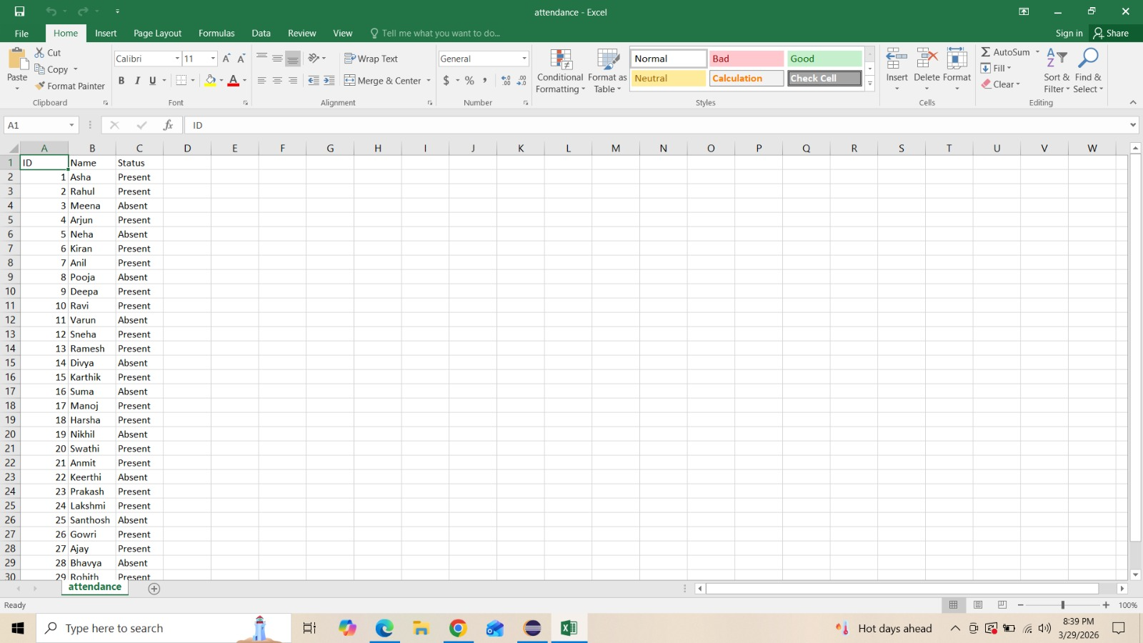
Fig 3.2 Attendance CSV File
After attendance values are processed by the AttendanceReader module, they are stored inside the Classroom.java class, which acts as the logical representation of classroom structure within the digital twin environment. The Classroom class maintains parameters such as total classroom seating capacity, number of students present, and occupancy-related variables required by visualization and prediction modules. Instead of interacting directly with the graphical interface, this class functions as a structured data container that supplies occupancy information to other components such as ClassroomPanel and AttendancePredictor. By separating classroom data storage from visualization logic, the implementation follows object-oriented design principles that improve maintainability and modularity of the system architecture.

The graphical representation of classroom seating arrangement is implemented using the ClassroomPanel.java module, which converts attendance values stored inside the Classroom object into a spatial visualization of student seating distribution. This module uses GridLayout structures to create a matrix of seat indicators where each grid cell represents a physical seat inside the classroom environment.
Based on the number of students marked present in the CSV attendance file, the corresponding number of seats is highlighted visually on the dashboard panel while remaining seats appear inactive. This seat visualization panel acts as the digital twin representation of classroom occupancy structure because it transforms numerical attendance information into a graphical model that resembles a real classroom seating layout. Through this visualization, users can observe how many seats are occupied and how classroom space is being utilized during lecture sessions.
The simulation of classroom environmental conditions is performed using the EnvironmentModel.java class, which generates temperature values dynamically during program execution. Since the system does not include physical IoT temperature sensors, environmental monitoring is implemented using simulation logic that continuously updates temperature values based on predefined variation parameters.
These generated temperature readings typically fluctuate around realistic classroom temperature ranges such as 27°C to 29°C and are refreshed periodically throughout the execution cycle. The updated temperature value is transmitted to the MainGUI module where it appears on the dashboard as a live classroom temperature indicator. This simulated environmental monitoring mechanism allows the digital twin dashboard to replicate sensor-like behavior without requiring external hardware devices.
The environmental values generated by the EnvironmentModel module are further processed by the AttendancePredictor.java class, which performs classroom comfort prediction analysis based on temperature thresholds. Although named AttendancePredictor, this module contributes significantly to evaluating classroom environmental suitability conditions.

It compares the simulated temperature value against predefined comfort ranges and determines whether the classroom environment remains comfortable for students. If the temperature lies within the acceptable threshold limits, the system displays a Comfortable status on the dashboard interface; otherwise, it displays a Not Comfortable message. This prediction result is continuously updated as temperature values change during execution, enabling the system to simulate intelligent environmental awareness similar to smart classroom monitoring platforms used in modern infrastructure systems.
Energy consumption behavior inside the classroom environment is simulated using the EnergyManager.java module, which generates dynamic energy usage values representing the power consumption of classroom equipment such as lights, fans, and projection systems. The energy consumption values produced by this module are influenced by lecture activity status controlled through the Toggle Lecture button implemented inside the MainGUI class. When lecture mode is active, the system assumes that classroom devices are operating at higher capacity, resulting in increased simulated energy consumption values displayed on the dashboard. When lecture mode is deactivated, the EnergyManager module reduces simulated energy usage values to represent an energy-saving classroom state. These dynamic energy values are continuously transmitted to both dashboard labels and the EnergyGraphPanel module for visualization purposes.
The graphical plotting of classroom energy consumption behavior is implemented using the EnergyGraphPanel.java class, which creates a waveform-style visualization representing energy usage variation over time. This module maintains an ArrayList data structure that stores recent energy readings generated by the EnergyManager class. Each time a new energy value is produced, it is added to the ArrayList using the addEnergy() method.
If the number of stored values exceeds a predefined threshold, older values are automatically removed to ensure that only recent energy activity remains visible in the graph. The graphical representation of these energy readings is implemented inside the paintComponent() method where Java Graphics objects draw connected line segments between stored energy values. This produces a zigzag waveform pattern that simulates real-time monitoring behavior similar to industrial energy tracking dashboards. The repaint() method ensures continuous refreshing of the graph whenever new energy readings are added, thereby creating a dynamic visualization effect inside the dashboard interface.
TABLE 3.2 Dashboard Parameters Displayed in System
Parameter | Source Module | Purpose
Attendance Count | AttendanceReader.java | Shows number of students present
Seat Layout | ClassroomPanel.java | Displays classroom occupancy visually
Temperature | EnvironmentModel.java | Shows simulated classroom temperature
Comfort Status | AttendancePredictor.java | Indicates classroom environment suitability
Energy Usage | EnergyManager.java | Shows simulated electricity consumption
Energy Graph | EnergyGraphPanel.java | Displays energy variation waveform
The interaction between classroom activity and environmental monitoring behavior is controlled through the Toggle Lecture button implemented inside the MainGUI class. When this button is pressed, an ActionListener event changes the lecture activity status variable inside the system, which directly influences both EnvironmentModel and EnergyManager modules. When lecture mode is enabled, the system simulates active classroom device operation and slightly increases environmental variation rates along with higher energy consumption values.
When lecture mode is disabled, the system reduces simulated device activity and lowers energy consumption values accordingly. These updates are immediately reflected on the dashboard interface, demonstrating automation control functionality similar to real smart classroom environments.
The Export Report feature implemented inside the MainGUI class allows the system to generate a structured monitoring report containing current classroom conditions displayed on the dashboard.

When the Export Report button is pressed, the system collects attendance count values from AttendanceReader, occupancy parameters from Classroom, temperature values from EnvironmentModel, comfort prediction results from AttendancePredictor, and energy consumption readings from EnergyManager.
These values are then written into a text-based report file using Java file writing utilities such as FileWriter and BufferedWriter. The generated report acts as a monitoring snapshot that records classroom environmental conditions and occupancy information at the moment the export operation is performed, thereby supporting documentation and performance tracking within the digital twin monitoring environment.
The internal working of the system can also be understood through its block diagram structure, where attendance data flows from the CSV input module into the AttendanceReader class, then into the Classroom data model, and further into the ClassroomPanel visualization module. Simultaneously, the EnvironmentModel generates temperature readings that are evaluated by the AttendancePredictor module to determine classroom comfort status.
The EnergyManager module generates simulated energy usage values that are plotted dynamically using the EnergyGraphPanel module. All these subsystem outputs are integrated by the MainGUI class and displayed within the dashboard interface. The Export Report module collects these runtime values and stores them as a structured output file representing classroom monitoring conditions.
Through the integration of these modules, the Digital Twin Classroom Dashboard successfully demonstrates how classroom occupancy monitoring, environmental condition simulation, energy usage tracking, comfort prediction analysis, visualization panels, automation control logic, and reporting functionality can be combined into a single intelligent monitoring interface capable of representing classroom infrastructure behavior inside a virtual digital twin environment suitable for smart campus applications.

Table 3.3 Software Modules and Their Functions
Module Name | Function in the System | Output displayed on Dashboard
MainGUI.java | Controls overall dashboard layout and integrates all modules | Displays attendance, temperature, comfort status, energy usage
Classroom.java | Stores classroom seating capacity and student presence data | Used by seat visualization panel
ClassroomPanel.java | Generates graphical classroom seating layout | Shows occupied and empty seats visually
AttendanceReader.java | Reads attendance data from CSV file | Provides attendance count
AttendancePredictor.java | Evaluates classroom comfort condition based on temperature | Displays comfort status
EnvironmentModel.java | Simulates classroom temperature values dynamically | Shows temperature updates
EnergyManager.java | Simulates classroom energy consumption | Displays energy usage values
EnergyGraphPanel.java | Plots energy usage variation graph | Shows real-time waveform graph
Export Report Feature | Saves classroom monitoring snapshot to file | Generates classroom monitoring report

Chapter 4
RESULTS AND DISCUSSION

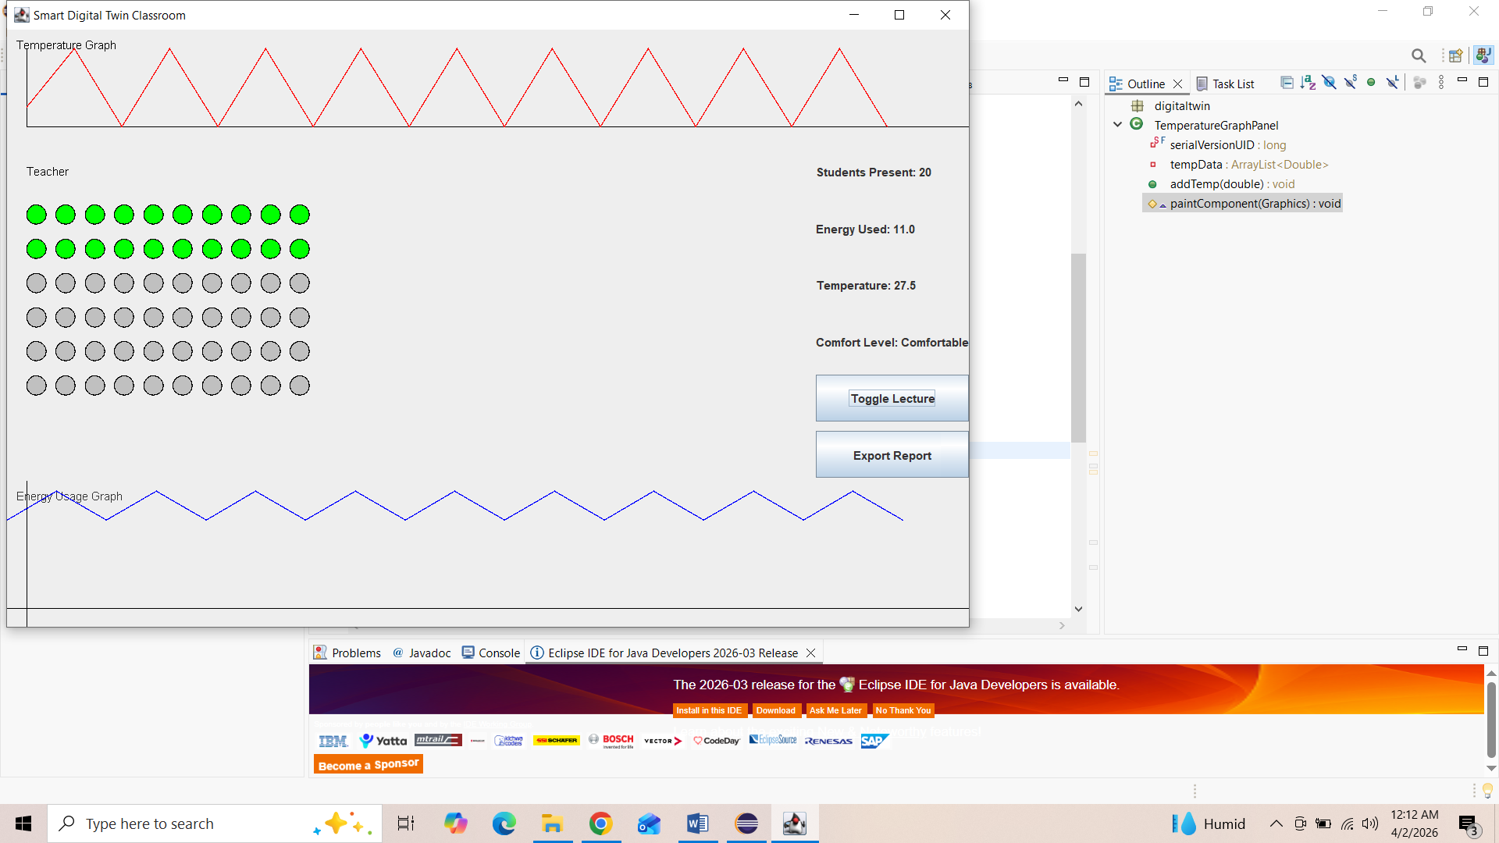
Fig 4.1 Dashboard Output Before Activating Lecture Mode
The fig 4.1 represents the initial execution state of the Smart Digital Twin Classroom Dashboard before pressing the Toggle Lecture button. In this stage, the system has successfully completed the attendance data loading process from the CSV file and initialized the graphical user interface components, including seat visualization layout, temperature display panel, comfort level indicator, and energy usage graph panel.
At the start of execution, the program reads the attendance CSV file using Java file-handling logic. Each row of the CSV file contains student attendance information, which is scanned sequentially using loops. During this scanning process, the system checks whether the attendance value is marked as Present. Whenever a present entry is detected, the attendance counter increases automatically. After processing all entries in the CSV file, the total number of students present is calculated and displayed on the dashboard interface.
Based on this attendance count, the classroom seat visualization grid is generated on the left side of the dashboard window. Each circular indicator in the grid represents one student seat inside the classroom. These indicators visually simulate classroom occupancy distribution and form the digital twin representation of the physical classroom seating structure. This visualization confirms that the attendance reader module is functioning correctly and that classroom occupancy information is successfully transferred into the graphical interface.
Before pressing the Toggle Lecture button, the lecture automation control module remains in its default condition. At this stage, simulated classroom device activity is still operating according to the initial environment settings defined inside the program. As a result, the dashboard displays an energy usage value around 11 units, which represents baseline classroom energy behavior generated by the simulation logic.
Similarly, the temperature value displayed on the dashboard is approximately 27.5°C, which represents the initial simulated environmental condition calculated by the temperature update module. This temperature falls within the predefined comfort threshold range implemented in the comfort evaluation logic. Therefore, the system displays the Comfortable status on the dashboard.
The energy usage graph plotted at the bottom of the interface shows a repeating waveform pattern rather than a straight constant line. This waveform appears because the EnergyGraphPanel continuously updates values using simulated variation logic implemented in the program. Even before pressing the Toggle Lecture button, energy values fluctuate slightly due to periodic simulation updates.
Thus, this output confirms successful execution of attendance processing, seat visualization, temperature initialization, comfort prediction logic, and real-time energy graph plotting modules before lecture mode switching occurs in the Smart Digital Twin Classroom Dashboard system.

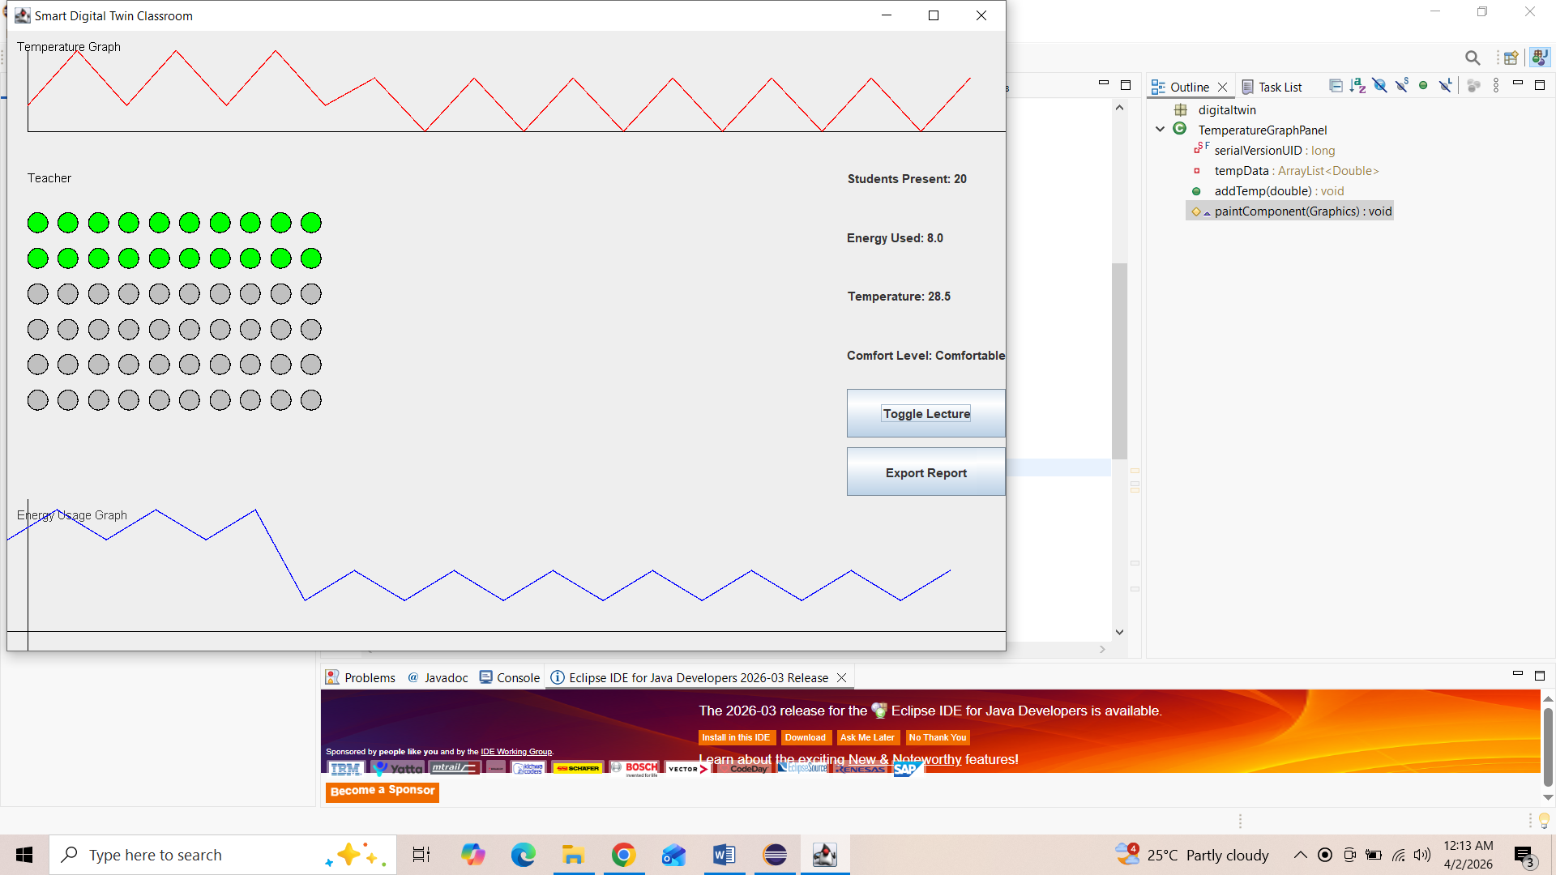
Fig 4.2 Dashboard Output After Activating Toggle Lecture Mode
The fig 4.2 represents the behavior of the Smart Digital Twin Classroom Dashboard after pressing the Toggle Lecture button. This step activates the automation control logic implemented inside the dashboard interface and modifies environmental simulation parameters displayed on the screen.
When the Toggle Lecture button is pressed, an event listener associated with the button changes the lecture status variable inside the program. This change directly affects the temperature simulation logic and energy update module implemented in the dashboard system. As a result, the environmental parameter values displayed on the interface are recalculated dynamically.
One of the most visible changes observed after pressing the Toggle Lecture button is the modification of the energy usage value. The dashboard now displays energy usage around 8 units, which is lower than the previous value displayed before pressing the toggle button. This reduction confirms that the lecture automation control module successfully switched the classroom from active device simulation mode to reduced activity mode inside the program logic.

Similarly, the temperature value shown on the dashboard changes from approximately 27.5°C to 28.5°C. This change occurs because the temperature simulation module continuously updates environmental values over time using incremental logic implemented in the system. The temperature change does not remain constant because the simulation continuously generates new environmental values during execution.
Even after the temperature increase, the comfort evaluation module still classifies the classroom condition as Comfortable because the temperature remains within the acceptable threshold range defined in the program.
The energy usage graph shown in the lower section of the dashboard continues to display a zig-zag waveform pattern. This behavior occurs because the EnergyGraphPanel adds new energy values continuously using the addEnergy() method implemented in the graph plotting module. Each new value shifts the graph forward and produces a moving waveform effect that simulates real-time monitoring behavior.
It is important to note that the seat visualization grid remains unchanged after pressing the Toggle Lecture button. This happens because attendance data is independent of lecture automation status and is only controlled by the CSV input file.
Thus, this output confirms successful functioning of lecture toggle automation logic, temperature update module, energy simulation update mechanism, comfort prediction logic, and continuous waveform graph plotting behavior in the Smart Digital Twin Classroom Dashboard system.
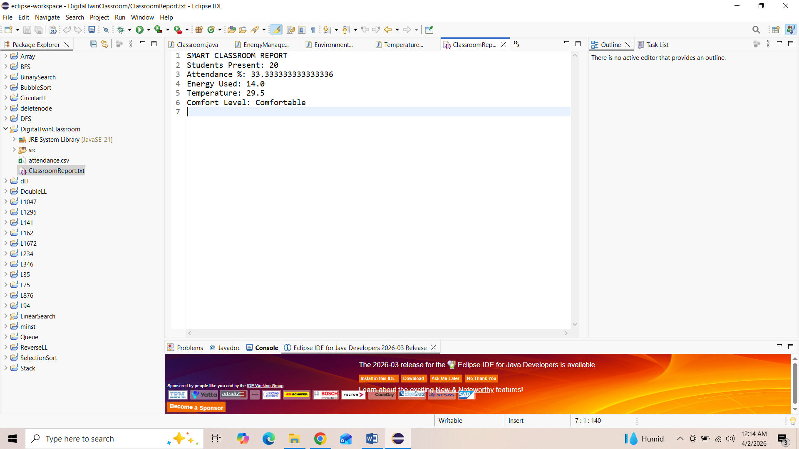
Fig 4.3 Classroom Monitoring Report After Export
The fig 4.3 represents the execution of the Export Report feature implemented in the Smart Digital Twin Classroom Dashboard system. This feature allows the system to generate a structured classroom monitoring report containing important environmental and attendance parameters displayed on the dashboard during runtime.
When the Export Report button is pressed, the program collects parameter values from multiple modules already running inside the system. These include attendance count obtained from the CSV reader module, attendance percentage calculated using classroom capacity values, temperature value generated by the environmental simulation module, energy usage value produced by the energy update logic, and comfort level status determined by the temperature evaluation module.
After collecting these parameter values, the report generation module writes them into a text-based report file using Java file writing operations implemented in the program. This file acts as a documentation record of classroom environmental conditions captured during system execution.
The attendance value included in the generated report matches the occupancy visualization displayed on the dashboard. This confirms correct integration between the CSV reader module and report generation logic. Similarly, the attendance percentage shown in the report is calculated automatically using the total classroom capacity defined in the program and the number of students marked present.
The temperature value recorded inside the report corresponds to the latest simulated temperature value available at the moment the Export Report button is pressed. Since temperature values update continuously during execution, the report always stores the most recent environmental reading.
Likewise, the energy usage value stored in the report corresponds to the latest simulated energy value plotted on the dashboard graph at the time of report generation. Because the energy graph continuously updates using simulated waveform logic, the stored energy value reflects the most recent simulation snapshot rather than an average value.

Finally, the comfort status included in the report confirms whether the classroom environmental condition remained suitable for learning activities at the moment of report generation.
Thus, this output verifies correct functioning of the report generation module and confirms successful integration between attendance processing, environmental monitoring simulation, comfort evaluation logic, and file writing operations in the Smart Digital Twin Classroom Dashboard system.

Chapter 5
CONCLUSION AND FUTURE SCOPE
5.1 CONCLUSION
The Smart Digital Twin Classroom Dashboard project successfully demonstrates the design and implementation of a virtual classroom monitoring system using a Java Swing–based graphical interface, CSV-based attendance processing, environmental simulation logic, automation control mechanisms, and real-time visualization modules. The primary objective of this project was to create a software-based digital twin model that represents classroom activity conditions through an interactive dashboard capable of monitoring occupancy status, temperature variations, energy consumption trends, and comfort level prediction. The results obtained from the implementation confirm that the system effectively simulates real classroom behavior and provides meaningful insights into classroom operational conditions.
One of the major achievements of the proposed system is the successful integration of attendance data processing with classroom visualization. The system reads attendance information from an external CSV file and dynamically calculates the number of students present in the classroom. This data is then used to generate a visual representation of classroom occupancy through seat indicators displayed on the dashboard interface. Such visualization improves the understanding of classroom utilization conditions without manual verification, thereby demonstrating the usefulness of digital twin models in educational environments.
Another important contribution of this project is the implementation of the lecture automation control mechanism using a toggle button. This feature allows switching between standby classroom mode and active lecture mode. When lecture mode is activated, simulated electrical devices such as lights, fans, projector, and air conditioning are assumed to operate, resulting in increased energy consumption and temperature variation within the virtual classroom environment. This behavior closely represents real-world classroom operation conditions and highlights how automation logic can be integrated into smart monitoring systems.
The environment monitoring module further enhances the effectiveness of the dashboard by generating simulated temperature values based on classroom activity status. These temperature values are analyzed using predefined thresholds to determine classroom comfort levels. The system successfully classifies environmental conditions into categories such as Comfortable, Hot, or Cold. This predictive feature transforms numerical environmental data into meaningful information that supports decision-making regarding classroom suitability for learning activities.
In addition to numerical parameter display, the project incorporates graph-based visualization modules that illustrate temperature and energy consumption trends over time. These dynamic graphs help users easily understand variations in classroom environmental conditions and electrical usage patterns. The graphical representation improves the interpretability of simulation results and makes the dashboard interface more interactive and user-friendly.
Another significant feature implemented in this project is the report generation module, which allows exporting classroom monitoring data into structured text or CSV format. This functionality enables documentation of attendance status, environmental parameters, comfort conditions, and energy consumption values for future analysis and record keeping. The integration of reporting capabilities demonstrates how digital twin systems can support both real-time monitoring and offline evaluation processes.
Overall, the Smart Digital Twin Classroom Dashboard project successfully demonstrates how software-based simulation techniques can replicate classroom operational behavior using graphical visualization and automation logic. The system provides a strong foundation for future development of intelligent classroom monitoring platforms and clearly illustrates the practical application of digital twin concepts in smart education environments.
5.2 FUTURE SCOPE
The proposed Smart Digital Twin Classroom Dashboard provides a strong foundation for developing intelligent classroom monitoring systems using software-based simulation techniques. Although the current system successfully demonstrates attendance visualization, temperature monitoring, energy usage simulation, comfort level prediction, lecture mode automation, and report generation features, there are several opportunities for further enhancement that can transform this model into a real-time smart classroom management platform.
One important future improvement is the integration of real-time hardware sensors such as temperature sensors, occupancy sensors, and smart energy meters. In the present implementation, temperature and energy values are generated using simulation logic within the program. By replacing simulated values with actual sensor data collected through microcontrollers such as Arduino or embedded platforms, the dashboard can represent real classroom environmental conditions more accurately. This would make the digital twin model suitable for deployment in real educational institutions.
Another possible enhancement is the addition of Internet of Things (IoT) connectivity, which would allow classroom monitoring data to be transmitted to cloud servers for remote access and centralized monitoring. With IoT integration, administrators and faculty members could monitor classroom conditions from mobile devices or web applications without being physically present inside the classroom. This would significantly improve usability and scalability of the system across multiple classrooms in a campus environment.
The system can also be extended by incorporating machine learning techniques to predict classroom environmental behavior and optimize energy usage automatically. For example, predictive algorithms can estimate temperature changes based on attendance patterns and automatically control classroom devices to maintain comfortable learning conditions while minimizing power consumption.
Another useful enhancement is implementing automatic attendance detection using computer vision techniques. Instead of reading attendance data from CSV files, cameras installed inside classrooms can detect student presence automatically using face recognition algorithms. This would eliminate manual attendance preparation and make the monitoring process fully automated.
Additionally, future versions of the system can include mobile application support and web-based dashboards to improve accessibility and user interaction. A centralized dashboard capable of monitoring multiple classrooms simultaneously can also be developed for campus-level smart infrastructure management.
Thus, with the integration of real-time sensors, IoT connectivity, intelligent prediction techniques, and automated attendance systems, the proposed Smart Digital Twin Classroom Dashboard can evolve into a complete smart classroom monitoring solution aligned with next-generation digital campus technologies.

REFERENCES

[1] M. S. Razzaq, B. Shah, F. Iqbal, M. Ilyas, and F. Maqbool, “DeepClassRooms: A Deep Learning-Based Digital Twin Framework for On-Campus Classrooms,” Neural Computing & Applications, 2022.
[2] Z. Pang, H. Zhao, Z. Tang, and F. Kong, “A Digital Twins-Based Smart Classroom Monitoring System,” in Proc. Int. Conf. Advanced Learning Technologies, 2023.
[3] K. Ahuja, “Classroom Digital Twins,” XRDS, 2023.
[4] J. B. Fernandez, M. Dhingra, S. Mandal, N. E. O’Connor, A. Kerr, et al., “Smart DCU Digital Twin: Towards Smarter Universities,” in Proc. IEEE Smart World Congress (SWC), 2023.
[5] J. Zhang, J. Zhu, W. Tu, M. Wang, Y. Yang, et al., “The Effectiveness of a Digital Twin Learning System in Assisting Engineering Education Courses,” Applied Sciences, vol. 14, no. 15, 2024.
[6] G. Ning, H. Luo, W. Yin, and Y. Zhang, “Application of Digital Twin Technology in Smart Education Systems,” Sustainability, vol. 16, 2024.
[7] N. C. M., S. Arunkumar, and M. S., “Role of Artificial Intelligence in Enhancing School Digital Twins,” Journal of Artificial Intelligence and Capsule Networks, vol. 7, no. 2, pp. 209–231, 2025.
[8] W. Zhai, J. Zhang, and T. Liu, “EDU-MATRIX: A Generative Cognitive Digital Twin Architecture for Education,” 2026.

